***UBER DATA ANALYSIS***

**BY**

* **SAKSHI MOGHA**
* **ANJALI NIMJE**
* **RIYA SONI**
* **RISHABH SHARMA**

|  |
| --- |
| **import** pandas **as** pd **import** numpy **as** np  **import** matplotlib.pyplot **as** plt **import** os  **import** seaborn **as** sns **import** time**,**datetime  **from** matplotlib.pyplot **import** figure |

In [1]:

In [2]:

|  |  |
| --- | --- |
| In [3]: Out[3]: | df **=** pd**.**read_csv("C:\\Users\\Sakshi\\Downloads\\My Uber Drives.csv")  df  **START_DATE* END_DATE* CATEGORY* START* STOP* MILES* PURPOSE\*** |

|  |  |  |  |  |  |  |  |
| --- | --- | --- | --- | --- | --- | --- | --- |
| **0** | 01-01-2016 21:11 | 01-01-2016 21:17 | Business | Fort Pierce | Fort Pierce | 5.1 | Meal/Entertain |
| **1** | 01-02-2016 01:25 | 01-02-2016 01:37 | Business | Fort Pierce | Fort Pierce | 5.0 | NaN |
| **2** | 01-02-2016 20:25 | 01-02-2016 20:38 | Business | Fort Pierce | Fort Pierce | 4.8 | Errand/Supplies |
| **3** | 01-05-2016 17:31 | 01-05-2016 17:45 | Business | Fort Pierce | Fort Pierce | 4.7 | Meeting |
| **4** | 01-06-2016 14:42 | 01-06-2016 15:49 | Business | Fort Pierce | West Palm  Beach | 63.7 | Customer Visit |
| **...** | ... | ... | ... | ... | ... | ... | ... |
| **1151** | 12/31/2016 13:24 | 12/31/2016 13:42 | Business | Kar?chi | Unknown  Location | 3.9 | Temporary Site |
| **1152** | 12/31/2016 15:03 | 12/31/2016 15:38 | Business | Unknown  Location | Unknown  Location | 16.2 | Meeting |
| **1153** | 12/31/2016 21:32 | 12/31/2016 21:50 | Business | Katunayake | Gampaha | 6.4 | Temporary Site |
| **1154** | 12/31/2016 22:08 | 12/31/2016 23:51 | Business | Gampaha | Ilukwatta | 48.2 | Temporary Site |

In [4]:

|  |  |  |  |  |  |  |  |
| --- | --- | --- | --- | --- | --- | --- | --- |
| 1. Totals 2. rows × 7 columns | | NaN | NaN | NaN | NaN 12204.7 | NaN |  |
|  | |  |  |  |  |  |  |
|  | df**.**info() |  |  |  |  |  |
|  | | | | | |

<class 'pandas.core.frame.DataFrame'> RangeIndex: 1156 entries, 0 to 1155

Data columns (total 7 columns):

# Column Non-Null Count Dtype

--- ------ -------------- -----

1. START_DATE* 1156 non-null object
2. END_DATE* 1155 non-null object
3. CATEGORY* 1155 non-null object
4. START* 1155 non-null object
5. STOP* 1155 non-null object
6. MILES* 1156 non-null float64
7. PURPOSE* 653 non-null object

dtypes: float64(1), object(6) memory usage: 63.3+ KB

|  |  |  |  |  |  |  |
| --- | --- | --- | --- | --- | --- | --- |
| In [5]:  Out[5]:  In [6]:  In [7]:  Out[7]: | df**.**isnull()**.**sum()  START_DATE* 0  END_DATE* 1  CATEGORY* 1  START* 1  STOP* 1  MILES* 0 PURPOSE* 503 dtype: int64 df **=** df**.**drop(1155)  df  **START_DATE* END_DATE\*** | **CATEGORY\*** | **START\*** | **STOP\*** | **MILES\*** | **PURPOSE\*** |

|  |  |  |  |  |  |  |  |
| --- | --- | --- | --- | --- | --- | --- | --- |
| **0** | 01-01-2016 21:11 | 01-01-2016 21:17 | Business | Fort Pierce | Fort Pierce | 5.1 | Meal/Entertain |
| **1** | 01-02-2016 01:25 | 01-02-2016 01:37 | Business | Fort Pierce | Fort Pierce | 5.0 | NaN |
| **2** | 01-02-2016 20:25 | 01-02-2016 20:38 | Business | Fort Pierce | Fort Pierce | 4.8 | Errand/Supplies |
| **3** | 01-05-2016 17:31 | 01-05-2016 17:45 | Business | Fort Pierce | Fort Pierce | 4.7 | Meeting |
| **4** | 01-06-2016 14:42 | 01-06-2016 15:49 | Business | Fort Pierce | West Palm  Beach | 63.7 | Customer Visit |
| **...** | ... | ... | ... | ... | ... | ... | ... |
| **1150** | 12/31/2016 1:07 | 12/31/2016 1:14 | Business | Kar?chi | Kar?chi | 0.7 | Meeting |
| **1151** | 12/31/2016 13:24 | 12/31/2016 13:42 | Business | Kar?chi | Unknown  Location | 3.9 | Temporary Site |
| **1152** | 12/31/2016 15:03 | 12/31/2016 15:38 | Business | Unknown  Location | Unknown  Location | 16.2 | Meeting |
| **1153** | 12/31/2016 21:32 | 12/31/2016 21:50 | Business | Katunayake | Gampaha | 6.4 | Temporary Site |
| **1154** | 12/31/2016 22:08 | 12/31/2016 23:51 | Business | Gampaha | Ilukwatta | 48.2 | Temporary Site |
| 1155 rows × 7 columns | | |
| In [8]:  *#Now lets rename the columns first. To make my code easy to understand i am renaming* df **=** df**.**rename(columns **=** {df**.**columns[0]:'startdate', df**.**columns[1]:'enddate', df**.**col  In [9]: df  Out[9]: **startdate enddate category start stop miles purpose** | | | | | | | |

|  |  |  |  |  |  |  |  |  |  |
| --- | --- | --- | --- | --- | --- | --- | --- | --- | --- |
|  | **0** | 01-01-2016 21:11 | 01-01-2016 21:17 | Business | Fort Pierce | Fort Pierce | 5.1 | Meal/Entertain |  |
|  | **1** | 01-02-2016 01:25 | 01-02-2016 01:37 | Business | Fort Pierce | Fort Pierce | 5.0 | NaN |  |
|  | **2** | 01-02-2016 20:25 | 01-02-2016 20:38 | Business | Fort Pierce | Fort Pierce | 4.8 | Errand/Supplies |  |
|  | **3** | 01-05-2016 17:31 | 01-05-2016 17:45 | Business | Fort Pierce | Fort Pierce | 4.7 | Meeting |  |
|  | **4** | 01-06-2016 14:42 | 01-06-2016 15:49 | Business | Fort Pierce | West Palm  Beach | 63.7 | Customer Visit |  |
|  | **...** | ... | ... | ... | ... | ... | ... | ... |  |
|  | **1150** | 12/31/2016 1:07 | 12/31/2016 1:14 | Business | Kar?chi | Kar?chi | 0.7 | Meeting |  |
|  | **1151** | 12/31/2016 13:24 | 12/31/2016 13:42 | Business | Kar?chi | Unknown  Location | 3.9 | Temporary Site |  |
|  | **1152** | 12/31/2016 15:03 | 12/31/2016 15:38 | Business | Unknown  Location | Unknown  Location | 16.2 | Meeting |  |
|  | **1153** | 12/31/2016 21:32 | 12/31/2016 21:50 | Business | Katunayake | Gampaha | 6.4 | Temporary Site |  |
| 12/31/2016  **1154**  22:08  1155 rows × 7 columns | | | 12/31/2016 23:51 | Business | Gampaha | Ilukwatta | 48.2 | Temporary Site |  |
|  | | |  |  |  |  |  |  |  |
|  | df | |  |  |  |  |  |  |
|  | | | | | | | |

**startdate enddate category start stop miles purpose**

In [10]:

# Out[10]: startdate enddate category start stop miles purpose

|  |  |  |  |  |  |  |  |
| --- | --- | --- | --- | --- | --- | --- | --- |
| **0** | 01-01-2016 21:11 | 01-01-2016 21:17 | Business | Fort Pierce | Fort Pierce | 5.1 | Meal/Entertain |
| **1** | 01-02-2016 01:25 | 01-02-2016 01:37 | Business | Fort Pierce | Fort Pierce | 5.0 | NaN |
| **2** | 01-02-2016 20:25 | 01-02-2016 20:38 | Business | Fort Pierce | Fort Pierce | 4.8 | Errand/Supplies |
| **3** | 01-05-2016 17:31 | 01-05-2016 17:45 | Business | Fort Pierce | Fort Pierce | 4.7 | Meeting |
| **4** | 01-06-2016 14:42 | 01-06-2016 15:49 | Business | Fort Pierce | West Palm  Beach | 63.7 | Customer Visit |
| **...** | ... | ... | ... | ... | ... | ... | ... |
| **1150** | 12/31/2016 1:07 | 12/31/2016 1:14 | Business | Kar?chi | Kar?chi | 0.7 | Meeting |
| **1151** | 12/31/2016 13:24 | 12/31/2016 13:42 | Business | Kar?chi | Unknown  Location | 3.9 | Temporary Site |
| **1152** | 12/31/2016 15:03 | 12/31/2016 15:38 | Business | Unknown  Location | Unknown  Location | 16.2 | Meeting |

|  |  |  |  |  |  |  |  |  |
| --- | --- | --- | --- | --- | --- | --- | --- | --- |
| 12/31/2016  **1153**  21:32 | | 12/31/2016 21:50 | Business | Katunayake | Gampaha | 6.4 | Temporary Site |  |
| 12/31/2016  **1154**  22:08  1155 rows × 7 columns | | 12/31/2016 23:51 | Business | Gampaha | Ilukwatta | 48.2 | Temporary Site |  |
|  | |  |  |  |  |  |  |  |
|  | df**.**isnull()**.**sum() |  |  |  |  |  |  |
|  |  |  |  |  |  |  |
| startdate 0 enddate 0 category 0 start 0 stop 0 miles 0 purpose 502 dtype: int64 | |  |  |  |  |  |  |  |
|  |  | |  |  |  |  |  |  |
| df**.**category**.**value_counts() | |  |  |  |  |  |
|  | | | | | | |

**startdate enddate category start stop miles purpose**

In [11]:

Out[11]:

In [12]:

|  |  |
| --- | --- |
| Out[12]: In [13]: | Business 1078  Personal 77  Name: category, dtype: int64  print("\n..........Average Length of the Trip..............\n")  print('Business:', round(df[df['category'] **==** 'Business']**.**miles**.**mean(), 3)) print('Personal:', round(df[df['category'] **==** 'Personal']**.**miles**.**mean(), 3)) print('Meal/Entertain:', round(df[df['purpose'] **==** 'Meal/Entertain']**.**miles**.**mean(), 3  ..........Average Length of the Trip..............  Business: 10.656  Personal: 9.321  Meal/Entertain: 5.698 |
| In [14]: In [15]: | *#Now to change the data types of start date and end date* df**.**startdate **=** pd**.**to_datetime(df**.**startdate) df**.**enddate **=** pd**.**to_datetime(df**.**enddate) |

df**.**info()

<class 'pandas.core.frame.DataFrame'> Int64Index: 1155 entries, 0 to 1154

Data columns (total 7 columns):

# Column Non-Null Count Dtype

--- ------ -------------- -----

1. startdate 1155 non-null datetime64[ns]
2. enddate 1155 non-null datetime64[ns]
3. category 1155 non-null object
4. start 1155 non-null object
5. stop 1155 non-null object
6. miles 1155 non-null float64 6 purpose 653 non-null object dtypes: datetime64[ns](2), float64(1), object(4) memory usage: 72.2+ KB

In [16]:

df

[

df

**.**

start

**.**

str

**.**

contains

(

'\?'

)

**==**

**True**

]

Out[16]:

**star**

**t**

**dat**

**e**

**enddat**

**e**

**cat**

**egor**

**y**

**star**

**t**

**st**

**op**

**miles**

**purpose**

|  |  |  |  |  |  |  |  |
| --- | --- | --- | --- | --- | --- | --- | --- |
| **140** | 2016-02-20 14:50:00 | 2016-02-20 15:54:00 | Business | R?  walpindi | R?walpindi | 23.1 | Meeting |
| **141** | 2016-02-20 16:59:00 | 2016-02-20 17:54:00 | Personal | R?  walpindi | Unknown  Location | 16.5 | NaN |
| **656** | 2016-08-15 09:05:00 | 2016-08-15 09:52:00 | Business | R?  walpindi | Unknown  Location | 15.6 | NaN |
| **670** | 2016-08-17 15:32:00 | 2016-08-17 15:47:00 | Business | R?  walpindi | Islamabad | 6.4 | NaN |
| **679** | 2016-08-19 10:57:00 | 2016-08-19 11:06:00 | Business | R?  walpindi | Unknown  Location | 2.0 | NaN |
| **696** | 2016-08-22 20:53:00 | 2016-08-22 21:31:00 | Business | R?  walpindi | R?walpindi | 4.1 | NaN |
| **697** | 2016-08-22 22:31:00 | 2016-08-22 23:00:00 | Business | R?  walpindi | Unknown  Location | 18.7 | NaN |
| **763** | 2016-09-19 06:18:00 | 2016-09-19 06:49:00 | Business | R?  walpindi | Unknown  Location | 18.2 | NaN |
| **788** | 2016-10-06 17:23:00 | 2016-10-06 17:40:00 | Business | R?  walpindi | Unknown  Location | 112.6 | NaN |
| **804** | 2016-10-12 19:18:00 | 2016-10-12 19:21:00 | Business | R?  walpindi | Unknown  Location | 18.4 | NaN |
| **811** | 2016-10-14 10:16:00 | 2016-10-14 10:52:00 | Business | R?  walpindi | Unknown  Location | 12.4 | NaN |
| **1119** | 2016-12-27 07:02:00 | 2016-12-27 07:14:00 | Business | Kar?chi | Kar?chi | 4.9 | Temporary Site |
| **1120** | 2016-12-27 08:37:00 | 2016-12-27 08:59:00 | Business | Kar?chi | Kar?chi | 5.0 | Meal/Entertain |
| **1121** | 2016-12-27 12:53:00 | 2016-12-27 12:57:00 | Business | Kar?chi | Kar?chi | 0.6 | Meal/Entertain |
| **1122** | 2016-12-27 14:49:00 | 2016-12-27 15:03:00 | Business | Kar?chi | Unknown  Location | 3.1 | Customer Visit |
| **1124** | 2016-12-27 19:19:00 | 2016-12-27 19:50:00 | Business | Kar?chi | Kar?chi | 5.5 | Customer Visit |
| **1125** | 2016-12-28 08:34:00 | 2016-12-28 09:06:00 | Business | Kar?chi | Unknown  Location | 10.3 | Meal/Entertain |
| **1127** | 2016-12-28 13:53:00 | 2016-12-28 14:01:00 | Business | Kar?chi | Kar?chi | 2.0 | Errand/Supplies |
| **1128** | 2016-12-28 15:04:00 | 2016-12-28 15:39:00 | Business | Kar?chi | Unknown  Location | 8.5 | Meal/Entertain |
| **1130** | 2016-12-28 18:33:00 | 2016-12-28 18:56:00 | Business | Kar?chi | Kar?chi | 3.8 | Errand/Supplies |
| **1131** | 2016-12-28 22:44:00 | 2016-12-28 23:18:00 | Business | Kar?chi | Kar?chi | 5.1 | Errand/Supplies |
| **1132** | 2016-12-29 00:49:00 | 2016-12-29 01:06:00 | Business | Kar?chi | Kar?chi | 3.8 | Errand/Supplies |

|  |  |  |  |  |  |  |  |  |  |  |
| --- | --- | --- | --- | --- | --- | --- | --- | --- | --- | --- |
|  | **1133** | 2016-12-29 09:44:00 | 2016-12-29 10:07:00 | Business | Kar?chi | | Unknown  Location | 11.6 | Meal/Entertain |  |
|  | **1135** | 2016-12-29 12:25:00 | 2016-12-29 12:33:00 | Business | Kar?chi | | Kar?chi | 1.4 | Errand/Supplies |  |
|  | **1136** | 2016-12-29 13:17:00 | 2016-12-29 13:24:00 | Business | Kar?chi | | Kar?chi | 1.1 | Errand/Supplies |  |
|  | **1137** | 2016-12-29 13:56:00 | 2016-12-29 14:11:00 | Business | Kar?chi | | Kar?chi | 4.1 | Airport/Travel |  |
|  | **1138** | 2016-12-29 14:42:00 | 2016-12-29 14:58:00 | Business | Kar?chi | | Kar?chi | 6.1 | Between  Offices |  |
|  | **1139** | 2016-12-29 15:05:00 | 2016-12-29 15:16:00 | Business | Kar?chi | | Kar?chi | 1.3 | Errand/Supplies |  |
|  | **1140** | 2016-12-29 18:59:00 | 2016-12-29 19:14:00 | Business | Kar?chi | | Unknown  Location | 3.0 | Meal/Entertain |  |
|  | **1142** | 2016-12-29 20:15:00 | 2016-12-29 20:45:00 | Business | Kar?chi | | Kar?chi | 7.2 | Meeting |  |
|  | **1143** | 2016-12-29 20:53:00 | 2016-12-29 21:42:00 | Business | Kar?chi | | Unknown  Location | 6.4 | NaN |  |
|  | **1145** | 2016-12-30 10:15:00 | 2016-12-30 10:33:00 | Business | Kar?chi | | Kar?chi | 2.8 | Errand/Supplies |  |
|  | **1146** | 2016-12-30 11:31:00 | 2016-12-30 11:56:00 | Business | Kar?chi | | Kar?chi | 2.9 | Errand/Supplies |  |
|  | **1147** | 2016-12-30 15:41:00 | 2016-12-30 16:03:00 | Business | Kar?chi | | Kar?chi | 4.6 | Errand/Supplies |  |
|  | **1148** | 2016-12-30 16:45:00 | 2016-12-30 17:08:00 | Business | Kar?chi | | Kar?chi | 4.6 | Meeting |  |
|  | **1149** | 2016-12-30 23:06:00 | 2016-12-30 23:10:00 | Business | Kar?chi | | Kar?chi | 0.8 | Customer Visit |  |
|  | **1150** | 2016-12-31 01:07:00 | 2016-12-31 01:14:00 | Business | Kar?chi | | Kar?chi | 0.7 | Meeting |  |
|  | **1151** | 2016-12-31 13:24:00 | 2016-12-31 13:42:00 | Business | Kar?chi | | Unknown  Location | 3.9 | Temporary Site |  |
|  |  | | | | |  | |  |  |  |
| df['start'] **=** df['start']**.**replace({"\?":"a"}, regex | | | | | **=** **True**) | |  |  |
|  | df["stop"] **=** df["stop"]**.**replace({"\?":"a"}, regex **=** | | | | | **True**) | |  |  |  |
|  | | | | |  | |  |  |
|  |  | | | | |  | |  |  |  |
|  |  | | | | |  | |  |  |  |
| df | | | | |  | |  |  |
|  | | | | | | | | |

**startdate enddate category start stop miles purpose**

In [17]:

In [18]:

# Out[18]: startdate enddate category start stop miles purpose

|  |  |  |  |  |  |  |  |
| --- | --- | --- | --- | --- | --- | --- | --- |
| **0** | 2016-01-01 21:11:00 | 2016-01-01 21:17:00 | Business | Fort Pierce | Fort Pierce | 5.1 | Meal/Entertain |
| **1** | 2016-01-02 01:25:00 | 2016-01-02 01:37:00 | Business | Fort Pierce | Fort Pierce | 5.0 | NaN |
| **2** | 2016-01-02 20:25:00 | 2016-01-02 20:38:00 | Business | Fort Pierce | Fort Pierce | 4.8 | Errand/Supplies |

**startdate enddate category start stop miles purpose**

|  |  |  |  |  |  |  |  |
| --- | --- | --- | --- | --- | --- | --- | --- |
| **3** | 2016-01-05 17:31:00 | 2016-01-05 17:45:00 | Business | Fort Pierce | Fort Pierce | 4.7 | Meeting |
| **4** | 2016-01-06 14:42:00 | 2016-01-06 15:49:00 | Business | Fort Pierce | West Palm  Beach | 63.7 | Customer Visit |
| **...** | ... | ... | ... | ... | ... | ... | ... |
| **1150** | 2016-12-31 01:07:00 | 2016-12-31 01:14:00 | Business | Karachi | Karachi | 0.7 | Meeting |
| **1151** | 2016-12-31 13:24:00 | 2016-12-31 13:42:00 | Business | Karachi | Unknown  Location | 3.9 | Temporary Site |
| **1152** | 2016-12-31 15:03:00 | 2016-12-31 15:38:00 | Business | Unknown  Location | Unknown  Location | 16.2 | Meeting |
| **1153** | 2016-12-31 21:32:00 | 2016-12-31 21:50:00 | Business | Katunayake | Gampaha | 6.4 | Temporary Site |
| **1154** | 2016-12-31 22:08:00 | 2016-12-31 23:51:00 | Business | Gampaha | Ilukwatta | 48.2 | Temporary Site |

1155 rows × 7 columns

In [19]:

|  |  |
| --- | --- |
| In [20]: Out[20]: | print("Popular Starting Points \n..................\n",df**.**start**.**sort_values()**.**value_  Popular Starting Points  ..................  Cary 201 Unknown Location 148  Morrisville 85  Whitebridge 68  Islamabad 57 ...  Tribeca 1  Mcvan 1  NOMA 1  Eastgate 1  Townes at Everett Crossing 1  Name: start, Length: 175, dtype: int64 df**.**stop**.**sort_values()**.**value_counts()  Cary 203  Unknown Location 149  Morrisville 84  Whitebridge 65  Islamabad 58 ...  Nugegoda 1  Isles of Buena Vista 1  Seattle 1  St Thomas 1  University District 1  Name: stop, Length: 186, dtype: int64 |

In [21]: df["year"] **=** df**.**startdate**.**dt**.**year df["month"] **=** df**.**startdate**.**dt**.**month df["date"] **=** df**.**startdate**.**dt**.**date

df["week"] **=** df**.**startdate**.**dt**.**isocalendar()**.**week df["time"] **=** df**.**startdate**.**dt**.**time

df["minutes"] **=** (df["enddate"]**-**df["startdate"])**.**dt**.**total_seconds()**/**60

In [22]:

|  |
| --- |
| df |

# Out[22]: startdate enddate category start stop miles purpose year month da

|  |  |  |  |  |  |  |  |  |  |  |
| --- | --- | --- | --- | --- | --- | --- | --- | --- | --- | --- |
| **0** | 2016-01-  01 21:11:00 | 2016-  01-01 21:17:00 | Business | Fort Pierce | Fort  Pierce | 5.1 | Meal/Entertain | 2016 | 1 | 201  01- |
| **1** | 2016-01-  02 01:25:00 | 2016-  01-02 01:37:00 | Business | Fort Pierce | Fort  Pierce | 5.0 | NaN | 2016 | 1 | 201  01- |
| **2** | 2016-01-  02 20:25:00 | 2016-  01-02 20:38:00 | Business | Fort Pierce | Fort  Pierce | 4.8 | Errand/Supplies | 2016 | 1 | 201  01- |
| **3** | 2016-01-  05 17:31:00 | 2016-  01-05 17:45:00 | Business | Fort Pierce | Fort  Pierce | 4.7 | Meeting | 2016 | 1 | 201  01- |
| **4** | 2016-01-  06 14:42:00 | 2016-  01-06 15:49:00 | Business | Fort Pierce | West  Palm Beach | 63.7 | Customer Visit | 2016 | 1 | 201  01- |
| **...** | ... | ... | ... | ... | ... | ... | ... | ... | ... |  |
| **1150** | 2016-12-  31 01:07:00 | 2016-  12-31 01:14:00 | Business | Karachi | Karachi | 0.7 | Meeting | 2016 | 12 | 201  12- |
| **1151** | 2016-12-  31 13:24:00 | 2016-  12-31 13:42:00 | Business | Karachi | Unknown  Location | 3.9 | Temporary Site | 2016 | 12 | 201  12- |
| **1152** | 2016-12-  31 15:03:00 | 2016-  12-31 15:38:00 | Business | Unknown  Location | Unknown  Location | 16.2 | Meeting | 2016 | 12 | 201  12- |
| **1153** | 2016-12-  31 21:32:00 | 2016-  12-31 21:50:00 | Business | Katunayake | Gampaha | 6.4 | Temporary Site | 2016 | 12 | 201  12- |
| **1154** | 2016-12-  31 22:08:00 | 2016-  12-31 23:51:00 | Business | Gampaha | Ilukwatta | 48.2 | Temporary Site | 2016 | 12 | 201  12- |

|  |
| --- |
| fig_dims **=** (15, 15)  fig, ax **=** plt**.**subplots(figsize**=**fig_dims) gg **=** sns**.**countplot(x **=** "week", ax **=** ax, data **=** df) p1 **=** plt**.**setp(gg**.**get_xticklabels(), rotation **=** 90) plt**.**title("Rides per week in Year 2016", fontsize **=** 20) plt**.**xlabel("Week Numbers", fontsize **=** 25) plt**.**ylabel("Counts", fontsize **=** 25) |

1155 rows × 13 columns

In [23]:

Out[23]: Text(0, 0.5, 'Counts')

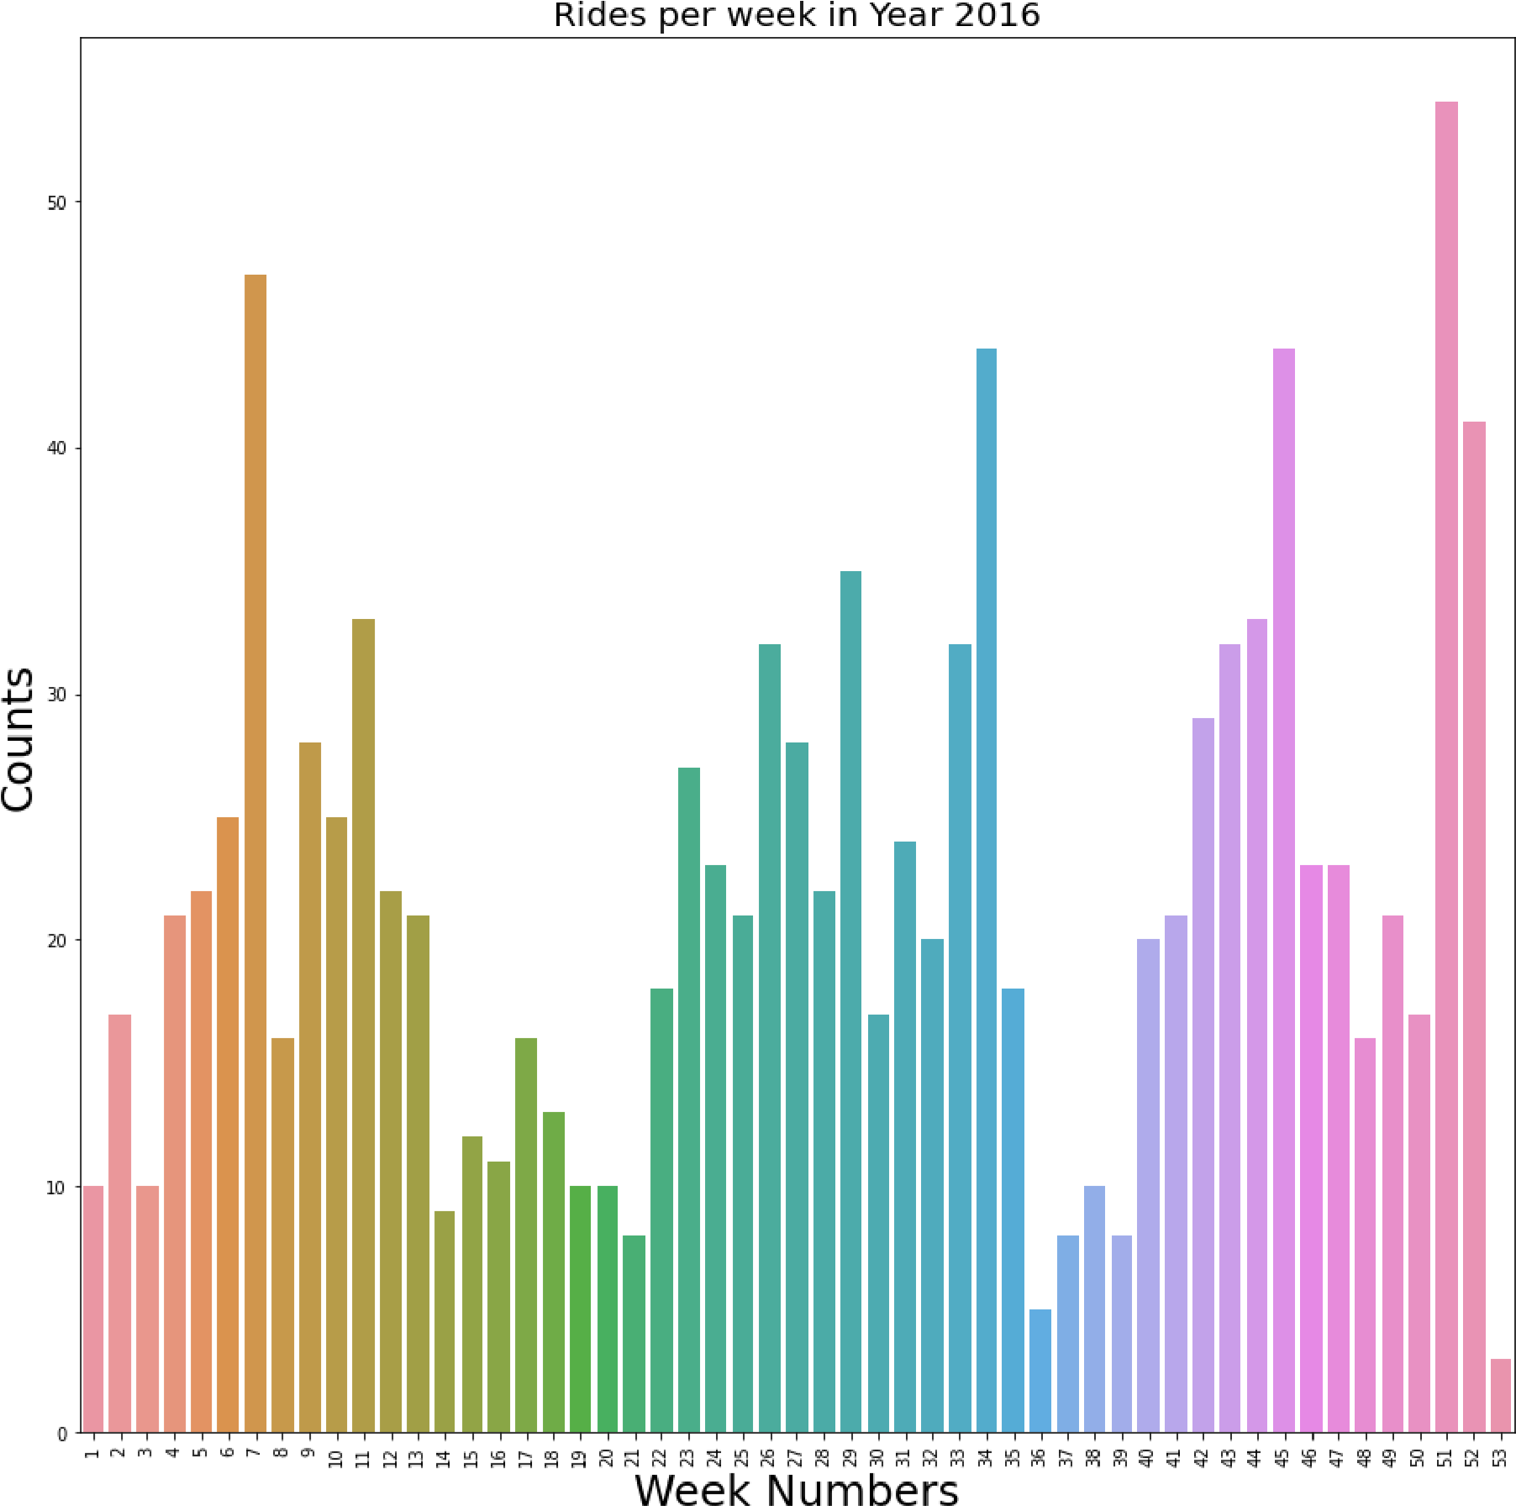

In [24]:

|  |
| --- |
| sns**.**relplot(x **=** "week", y **=** "miles", hue **=** "category", data **=** df) |

Out[24]: < seaborn.axisgrid.FacetGrid at 0x2a4ce92c0d 0>

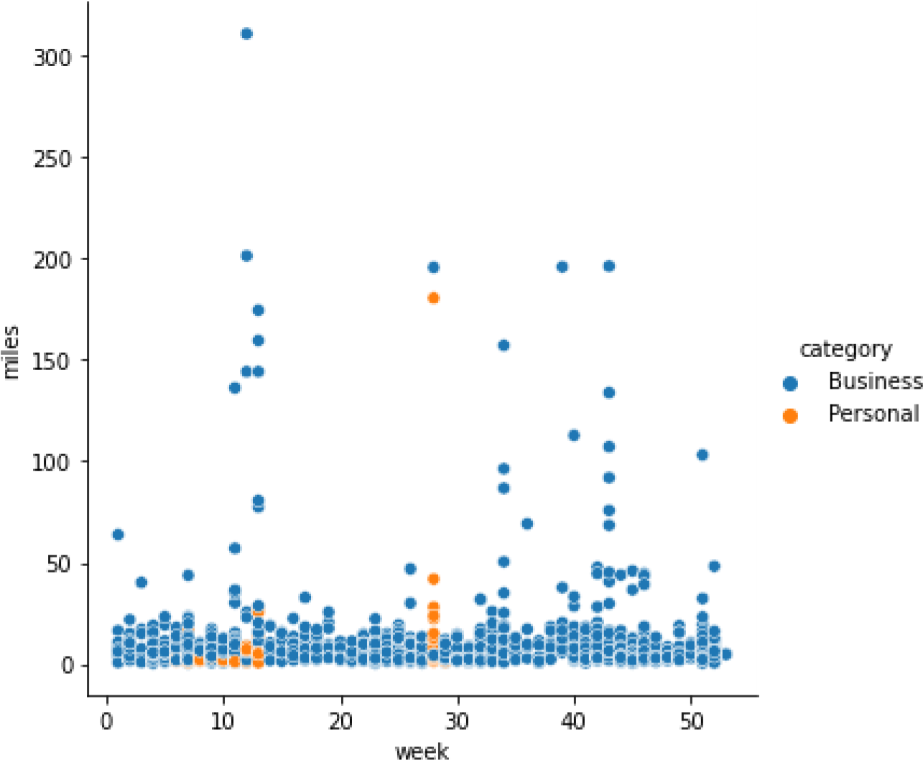

In [25]: sns**.**distplot(df["week"])

C:\Users\Sakshi\anaconda3\lib\site-packages\seaborn\distributions.py:2557: FutureWar ning: `distplot` is a deprecated function and will be removed in a future version. P lease adapt your code to use either `displot` (a figure-level function with similar flexibility) or `histplot` (an axes-level function for histograms). warnings.warn(msg, FutureWarning)

Out[25]: < AxesSubplot:xlabel='week', ylabel='Density' >

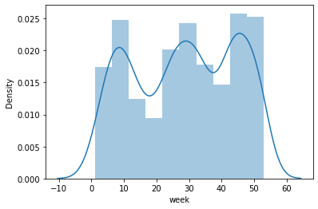

In [26]:

|  |
| --- |
| sns**.**countplot(x **=** "time", data **=** df) |

Out[26]: < AxesSubplot:xlabel='time', ylabel='count' >

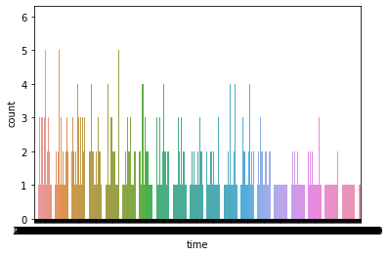

In [27]: df[df['category'] **==** 'Business']['week']**.**value_counts()[:10]**.**sort_values()**.**plot**.**barh plt**.**title("Number of Business Rides") plt**.**xlabel("Number of BUsiness Rides") plt**.**ylabel("Weeks")

Out[27]: Text(0, 0.5, 'Weeks')

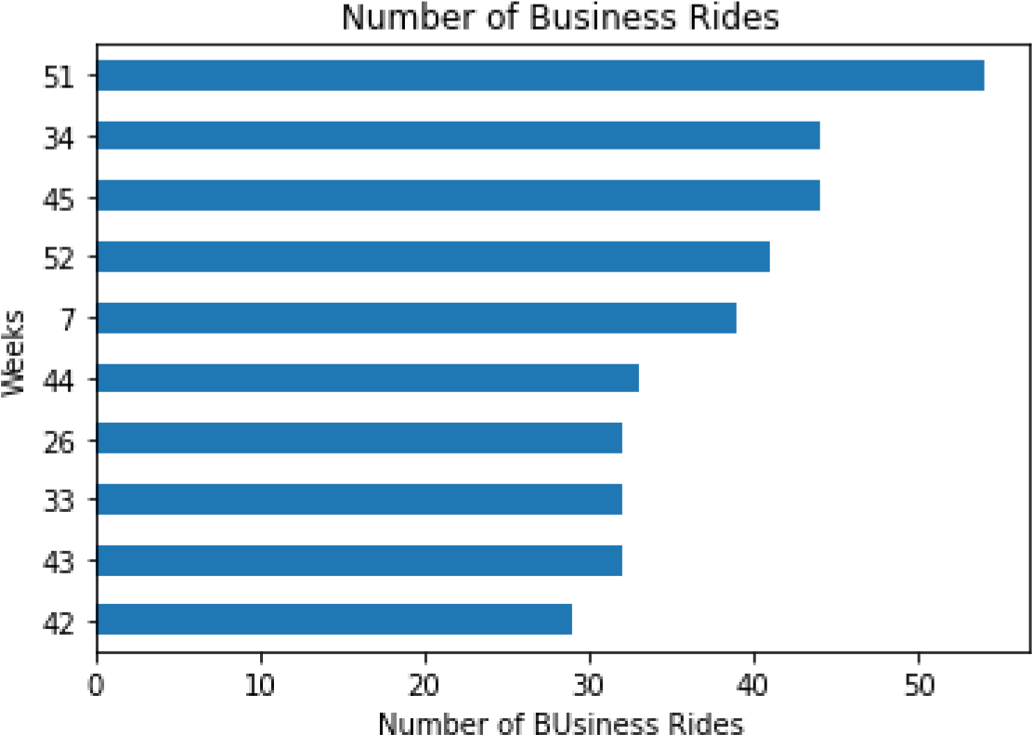

In [28]:

|  |
| --- |
| df[df["purpose"] **==** 'Meal/Entertain']["week"]**.**value_counts()[:10]**.**sort_values()**.**plot plt**.**title("Meal/Entertainment Visits")  plt**.**xlabel("Number of Meal/Entertainment Visits") plt**.**ylabel("Weeks") |

Out[28]: Text(0, 0.5, 'Weeks')

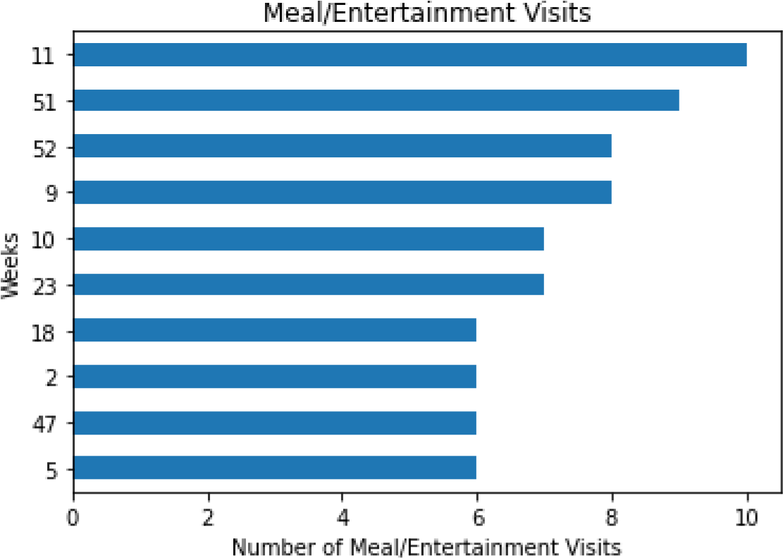

In [29]: df[df["category"]**==**"Personal"]["week"]**.**value_counts()[:10]**.**sort_values()**.**plot**.**barh() plt**.**title("Total Number of Personal Rides") plt**.**xlabel("Number of Personal Rides") plt**.**ylabel("Weeks") plt**.**show()

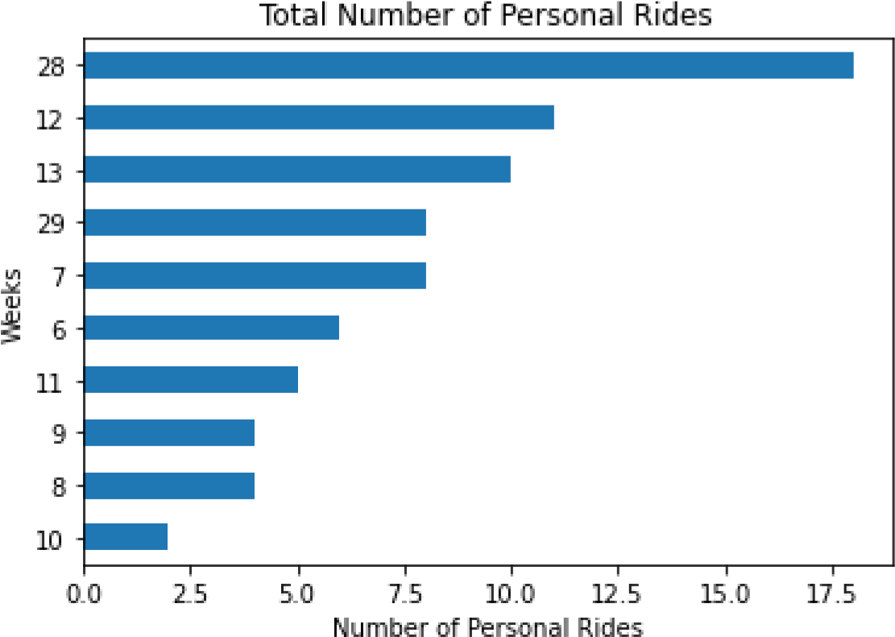

In [30]:

*# To calculate the Number of Miles Each Month the Traveler has Travelled* sns**.**barplot(x **=** "month", y **=** "miles", data **=** df)

Out[30]: < AxesSubplot:xlabel='month', ylabel='miles' >

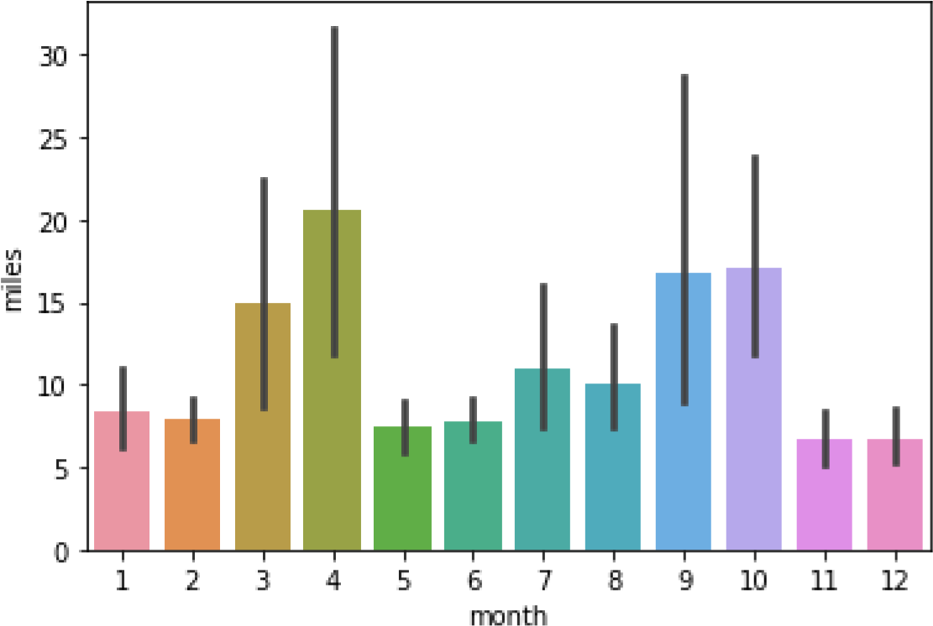

In [31]:

sns**.**countplot(y **=** "month", data **=** df)

Out[31]: < AxesSubplot:xlabel='count', ylabel='month' >

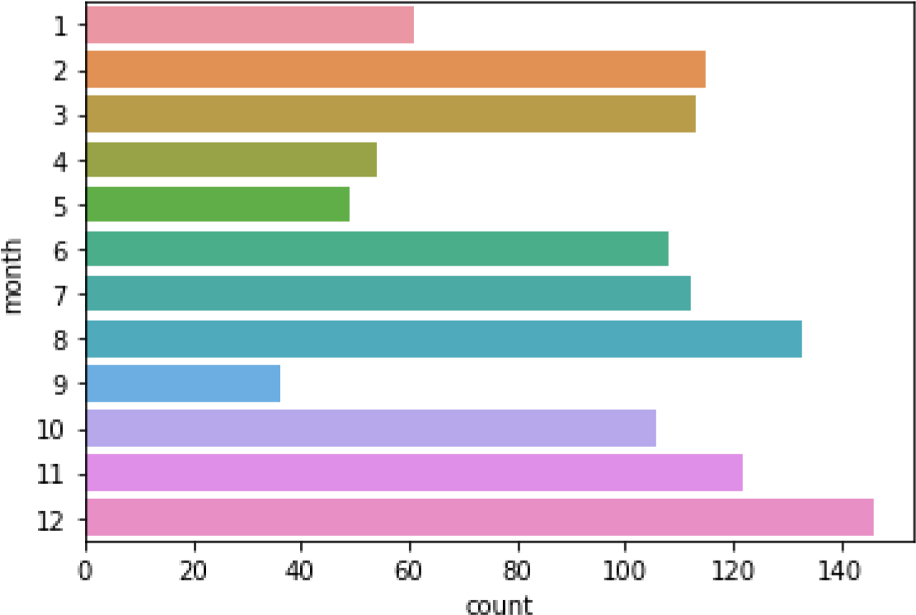

In [32]: sns**.**barplot(x **=** "month", y **=** "minutes", data **=** df)

>

<

AxesSubplot:xlabel='month', ylabel='minutes'

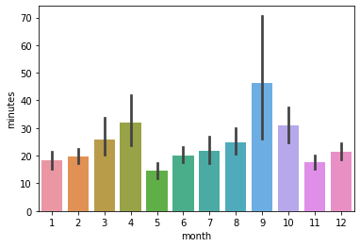

fig_dims

**=**

(

15

,

15

)

fig

,

ax

**=**

plt

**.**

subplots

(

figsize

**=**

fig_dims

)

Out[32]:

In [33]:

df**.**plot(x **=** 'week', y **=** 'minutes', ax **=** ax) df**.**plot(x **=** 'week', y **=** 'miles', ax **=** ax, secondary_y **=** **True**)

Out[33]: < AxesSubplot:label='3955fef6-04a2-4b21-8af2-a4f15e3b6555' >

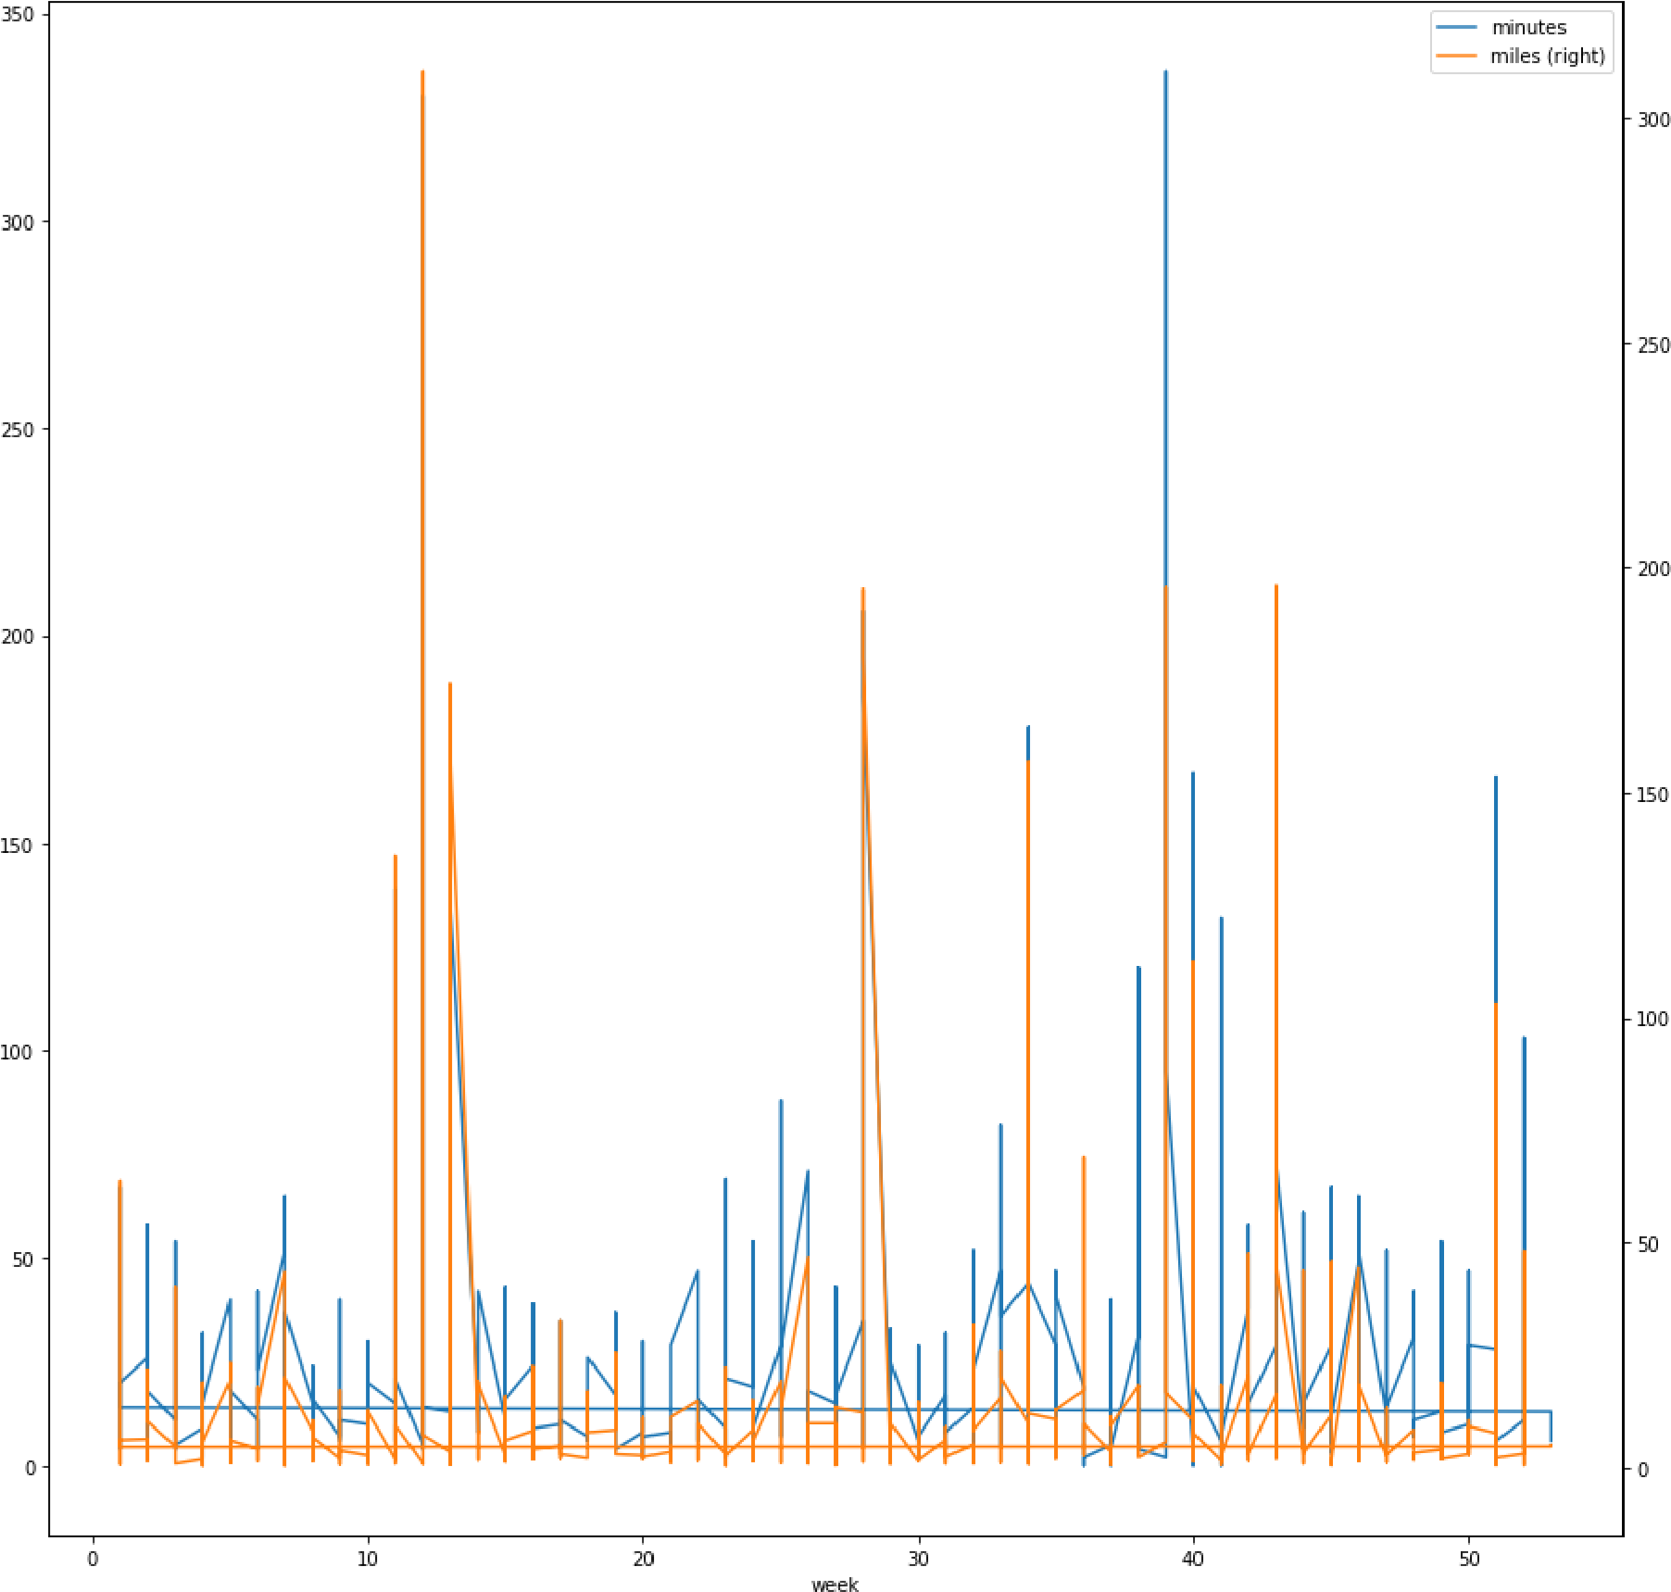

In [34]:

|  |
| --- |
| df["start"]**.**value_counts()[:25]**.**sort_values()**.**plot**.**bar() |

Out[34]: < AxesSubplot :>

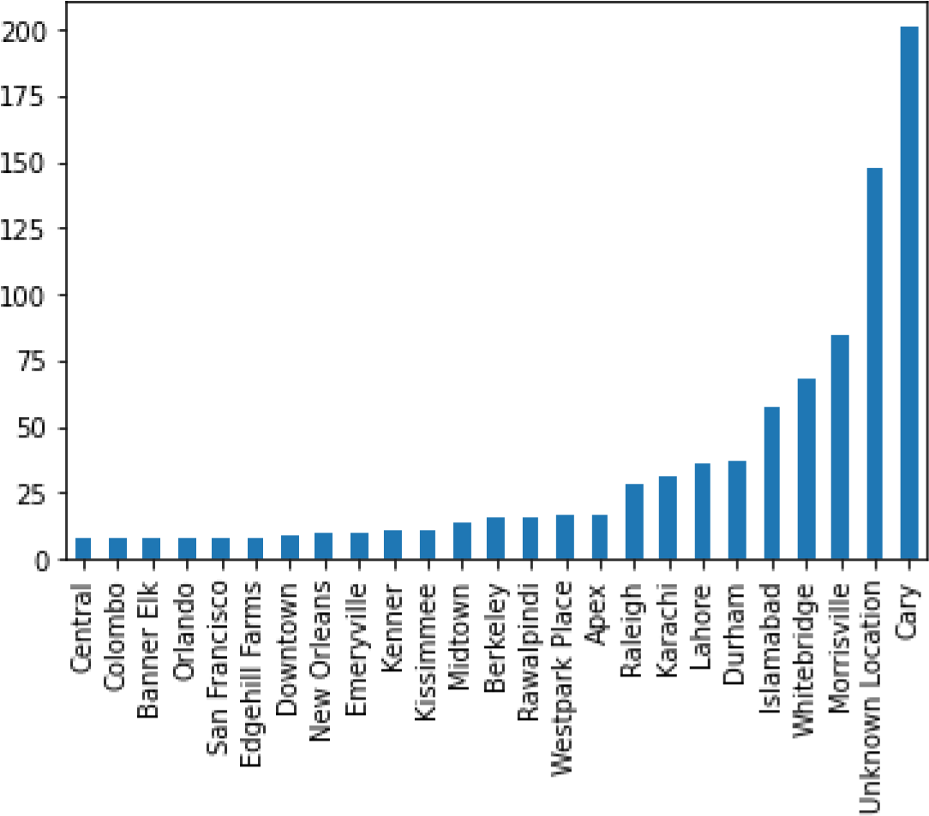

In [35]: df["stop"]**.**value_counts()[:25]**.**sort_values()**.**plot**.**bar()

Out[35]: < AxesSubplot :>

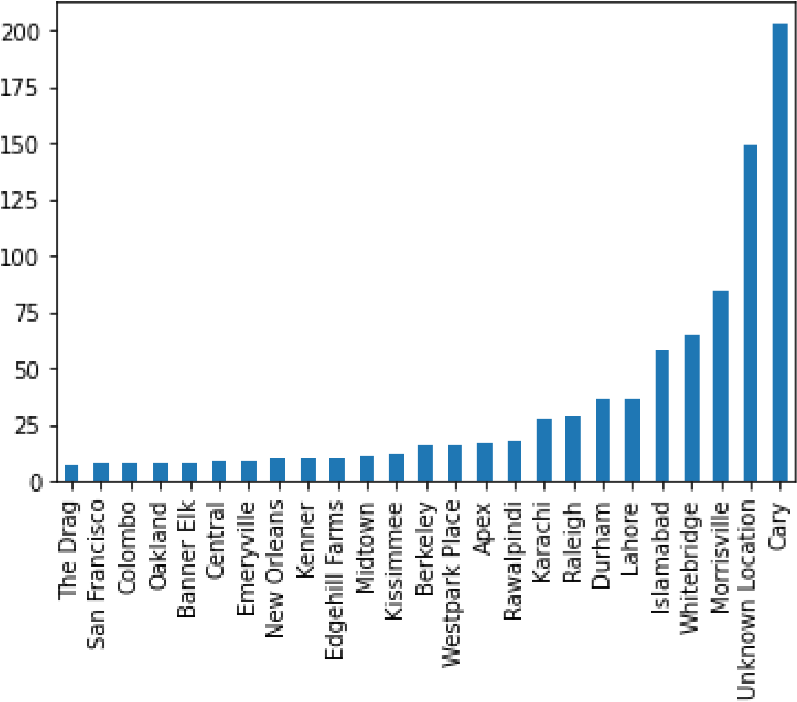

In [36]: fig_dims **=** (15, 15)

fig, ax **=** plt**.**subplots(figsize**=**fig_dims) sns**.**barplot(x **=** 'purpose', y **=** 'minutes', data **=** df, ax **=** ax)

Out[36]: < AxesSubplot:xlabel='purpose', ylabel='minutes' >

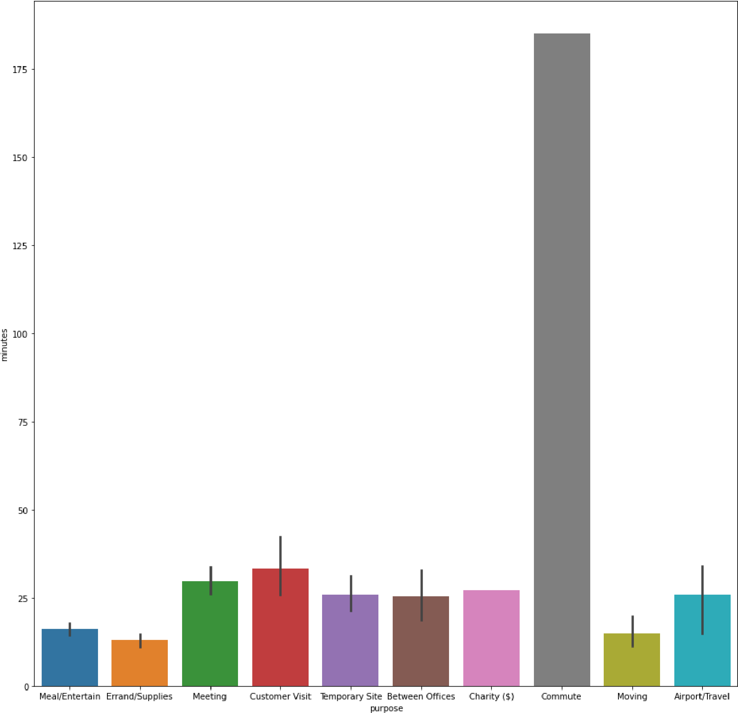

In [37]:

|  |
| --- |
| fig_dims **=** (15, 15)  fig, ax **=** plt**.**subplots(figsize**=**fig_dims)  sns**.**barplot(x **=** 'purpose', y **=** 'miles', data **=** df, ax **=** ax) plt**.**title("Purpose vs Miles Covered", fontsize **=** 40) plt**.**ylabel("Miles", fontsize **=** 30) plt**.**xlabel("Purpose", fontsize **=** 30) plt**.**xticks(rotation **=** 45, fontsize **=** 15) |

Out[37]: (array([0, 1, 2, 3, 4, 5, 6, 7, 8, 9]), [Text(0, 0, 'Meal/Entertain'),

Text(1, 0, 'Errand/Supplies'),

Text(2, 0, 'Meeting'),

Text(3, 0, 'Customer Visit'),

Text(4, 0, 'Temporary Site'),

Text(5, 0, 'Between Offices'),

Text(6, 0, 'Charity ($)'), Text(7, 0, 'Commute'),

Text(8, 0, 'Moving'),

Text(9, 0, 'Airport/Travel')])

|  |
| --- |
|  |

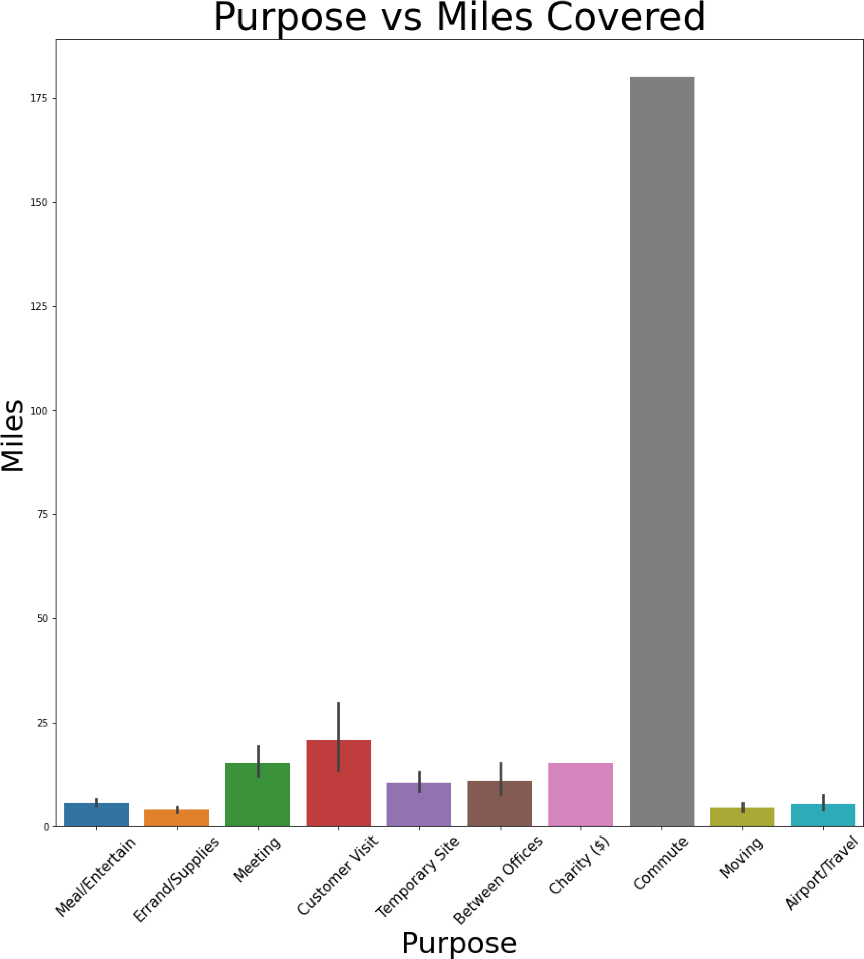In [ ]: